SMART CAMPUS PLACEMENT SYSTEM
Block Diagrams (all)
Department of Computer Science and Engineering, TKR College of Engineering & Technology
Batch C5 (CSE-C) · Academic year [ACADEMIC YEAR]
Table 1: Project team
S.No. | Student name | Roll number
1 | Mopidevi Bhagyasri | 23K91A05F9
2 | Pamulaparthi Harsha Vardan Reddy | 23K91A05J0
3 | Mohammad Faruk Baba | 23K91A05F3
4 | Prahalladh Terati | 23K91A05J8

Project guide: S Usha Devi
Chapter and section numbers quoted in the text (for example Chapter 8 or Section 6.2) refer to the full project report, 17.Final Document. Figures and tables in this document are numbered from 1.

1. INDEX OF DIAGRAMS
Every diagram was generated from the real design by scripts/make_diagrams.py (matplotlib, 150 dpi) and mirrors the code in backend/main.py, app.py and src/. The system has no SQL database, so the entity-relationship diagram shows the logical data model of the CSV and pickle files.
Table 2: Diagrams in this document
No. | Diagram | Image file
1 | System architecture | docs/diagrams/01_system_architecture.png
2 | High-level workflow | docs/diagrams/02_high_level_workflow.png
3 | Data flow diagram, level 0 (context) | docs/diagrams/03_dfd_level0.png
4 | Data flow diagram, level 1 | docs/diagrams/04_dfd_level1.png
5 | Data flow diagram, level 2 (process 4) | docs/diagrams/05_dfd_level2.png
6 | UML class diagram | docs/diagrams/06_class_diagram.png
7 | Sequence diagram: placement prediction | docs/diagrams/07_sequence_prediction.png
8 | Use-case diagram | docs/diagrams/08_use_case.png
9 | Entity-relationship diagram | docs/diagrams/09_er_diagram.png
10 | Flowchart of the core algorithm | docs/diagrams/10_core_algorithm_flowchart.png
11 | Training pipeline | docs/diagrams/11_training_pipeline.png
12 | Flowchart of the recommendation algorithm | docs/diagrams/12_recommendation_flowchart.png

2. DIAGRAMS

System architecture
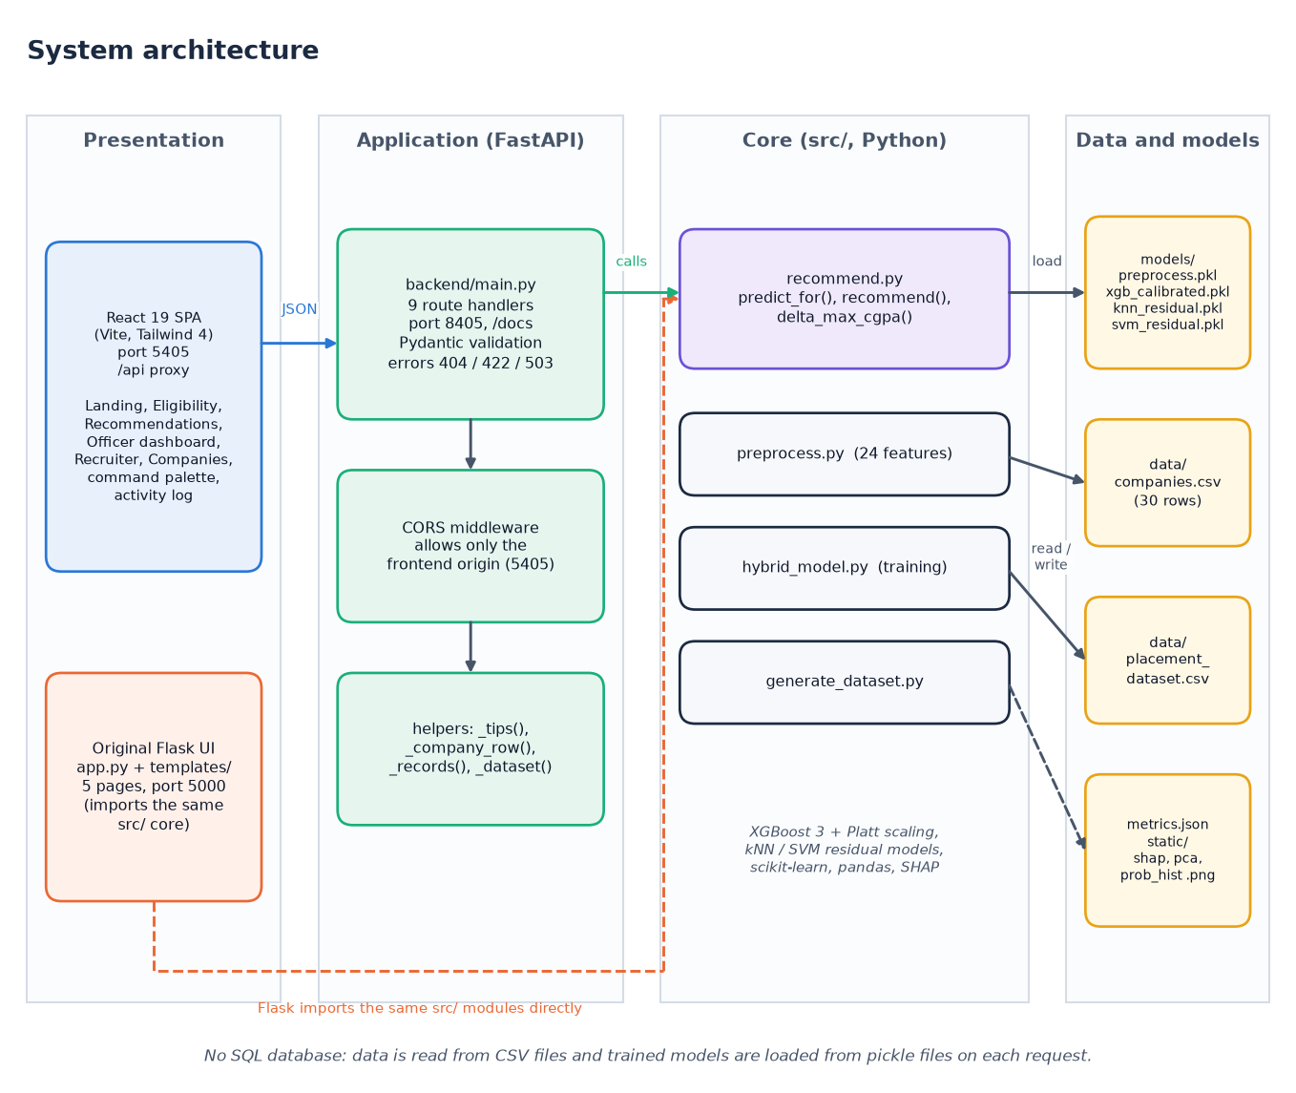
Figure 1: System architecture of the Smart Campus Placement System: presentation, application and core layers with the file stores.
The system has four columns. The presentation column holds the React 19 single-page application (Vite, Tailwind 4, port 5405) and the original Flask pages (app.py and five templates, port 5000). The application column is the FastAPI service backend/main.py (port 8405): nine route handlers, Pydantic validation, a CORS rule that admits only the front-end origin and a few helpers (_tips, _company_row, _records, _dataset). The core column is the src/ package: recommend.py serves predictions and recommendations, preprocess.py builds the 24 features, hybrid_model.py trains and evaluates, generate_dataset.py writes the synthetic data. The data column holds the two CSV tables, the five pickled model files with metrics.json, and three plot images. The FastAPI layer contains no model logic: it imports predict_for, recommend and pre_comp_cache from src/recommend.py, which is the same code the Flask app calls, so the two interfaces cannot drift apart. There is no SQL database; the pickled models are read from disk on each request.

High-level workflow
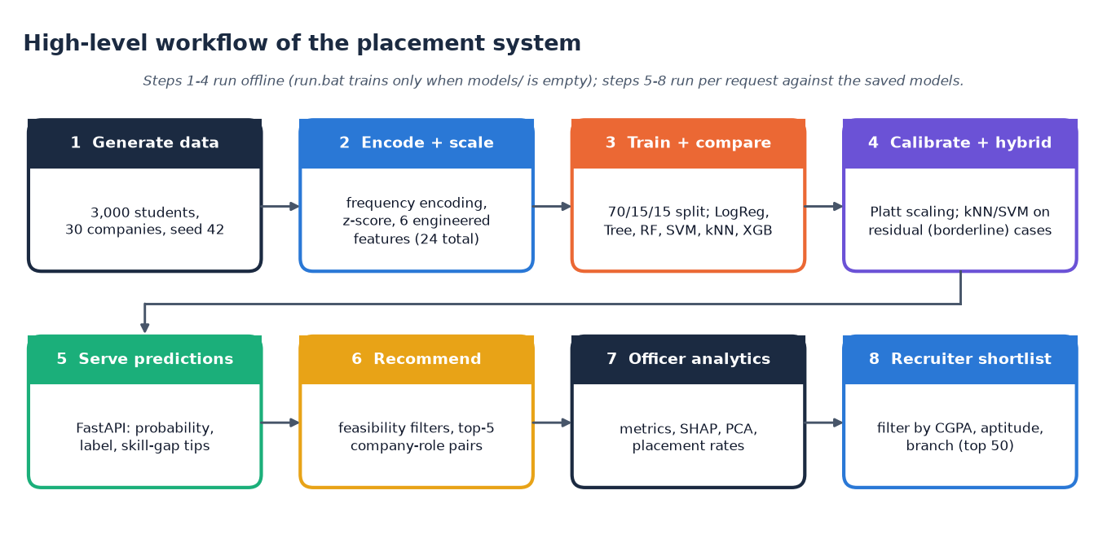
Figure 2: High-level workflow from data generation to recruiter shortlist.
The workflow has an offline half and an online half. Offline, generate_dataset.py writes 3,000 synthetic students and 30 companies (seed 42), preprocess.py frequency-encodes and standardises the features, and hybrid_model.py splits the data 70/15/15, trains six baseline classifiers, calibrates XGBoost with Platt scaling, builds the kNN and SVM residual models and writes the pickles, metrics.json and three plots. run.bat repeats this only when the model files are missing. Online, every request loads the saved models: the student pages ask for a probability or a recommendation, the officer dashboard reads the metrics and plots, and the recruiter page filters the student table.

Data flow diagram, level 0 (context)
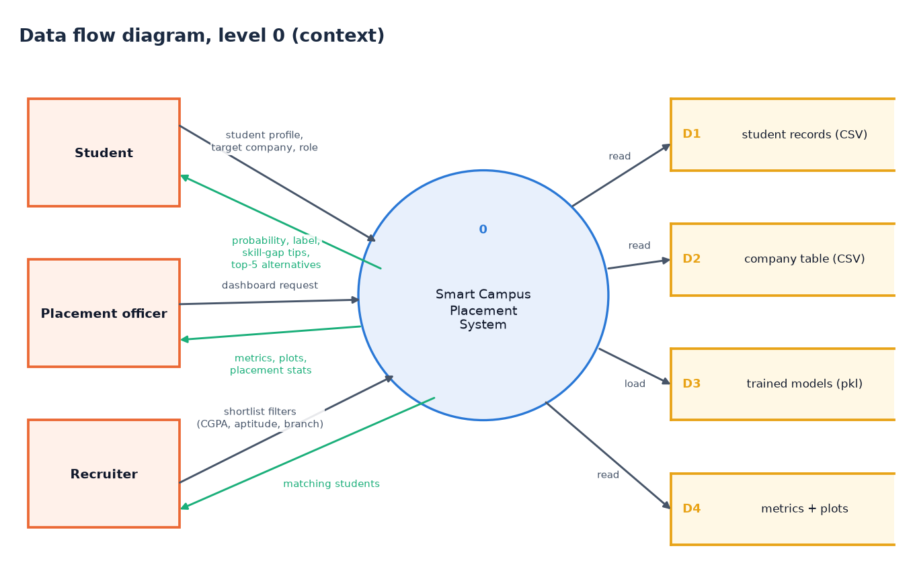
Figure 3: Level 0 data flow diagram: the system as one process with three external entities and four data stores.
At the context level the system is a single process. A student sends a profile with a target company and role and receives a probability, a label, skill-gap tips and up to five alternatives. A placement officer requests the dashboard and receives metrics, plots and placement statistics. A recruiter sends shortlist filters (CGPA, aptitude, branch) and receives matching students. The process reads the student records (D1), the company table (D2), the trained models (D3) and the metrics and plots (D4). Nothing is written at run time: the stores are only read.

Data flow diagram, level 1
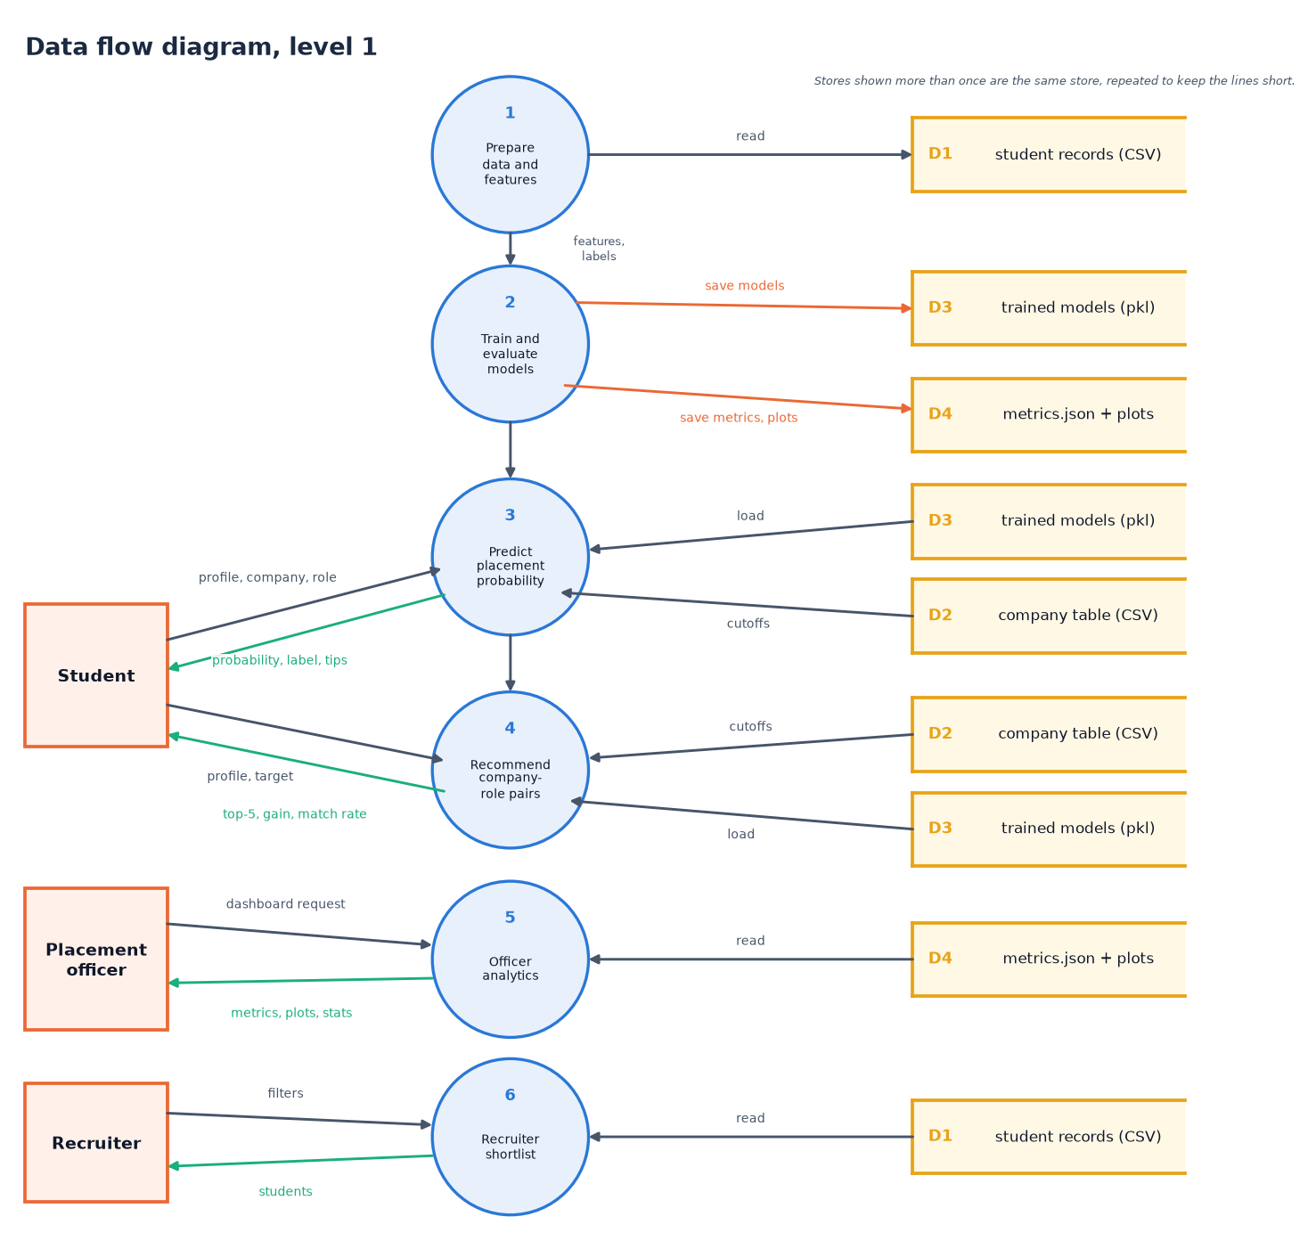
Figure 4: Level 1 data flow diagram: six processes, three external entities and four data stores.
Level 1 splits the process into six. Process 1 prepares the data and features from D1; process 2 trains and evaluates the models and writes the models to D3 and the metrics and plots to D4; process 3 predicts the placement probability from the models in D3 and the cutoffs in D2; process 4 recommends company-role pairs from the same two stores and the probability of process 3; process 5 serves the officer analytics from D4; process 6 filters D1 for the recruiter. Processes 1 and 2 run offline through the scripts in src/; processes 3 to 6 run per request. Stores shown more than once are the same store, repeated only to keep the arrows short.

Data flow diagram, level 2 (process 4)
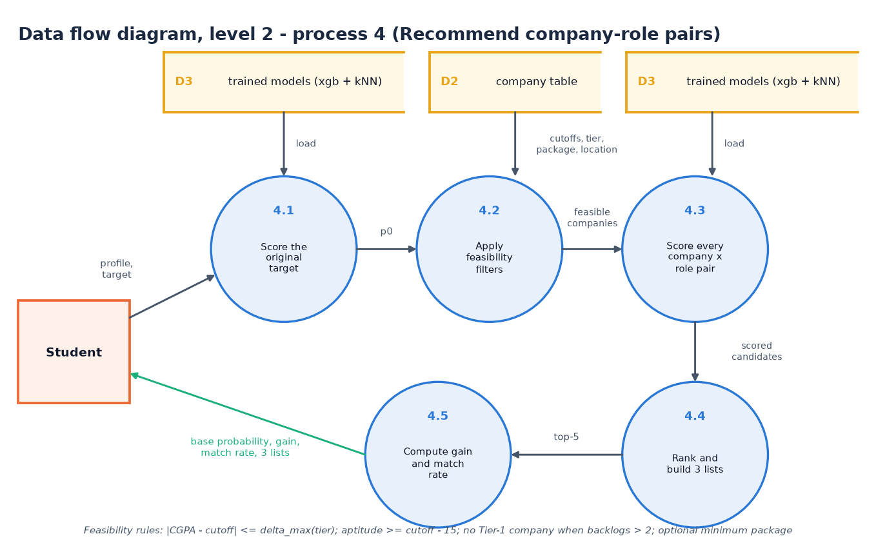
Figure 5: Level 2 data flow diagram of process 4, Recommend company-role pairs.
Process 4 is the most complex request, so it is decomposed. 4.1 scores the student's original target to obtain the base probability p0. 4.2 applies the feasibility filters to the 30 companies: the CGPA gap must not exceed delta_max of the company tier, aptitude must be at least the cutoff minus 15, a student with more than two backlogs is not offered Tier-1 companies, and an optional minimum package is honoured. 4.3 scores every feasible company with four roles (the target role, SDE, Data Analyst, QA Engineer). 4.4 ranks the candidates by score and builds the three lists, and 4.5 computes the average gain and the match rate. The trained models (D3) are read by 4.1 and 4.3, the company table (D2) by 4.2.

UML class diagram
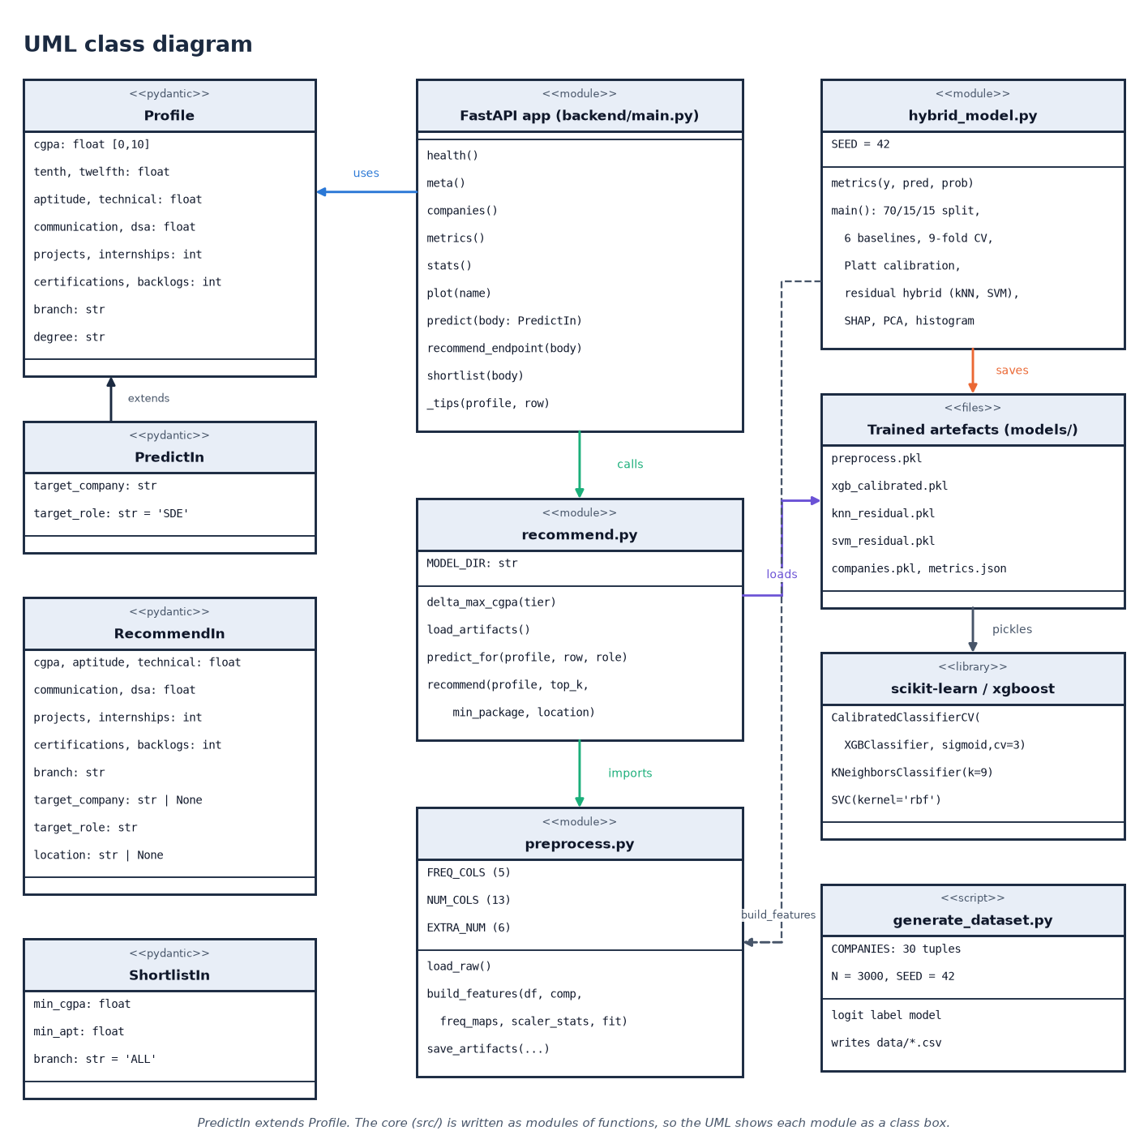
Figure 6: UML class diagram: request models, API module, core modules and the trained artefacts.
The code base is written as modules of functions with four Pydantic classes, so the diagram shows each module as a class box with its operations. PredictIn extends Profile; RecommendIn and ShortlistIn are independent request models. The API module uses them and calls recommend.py, which imports preprocess.py, loads the pickled artefacts and wraps scikit-learn and XGBoost objects (CalibratedClassifierCV around XGBClassifier, KNeighborsClassifier, SVC). hybrid_model.py saves the artefacts and uses build_features; generate_dataset.py writes the CSV files.

Sequence diagram: placement prediction
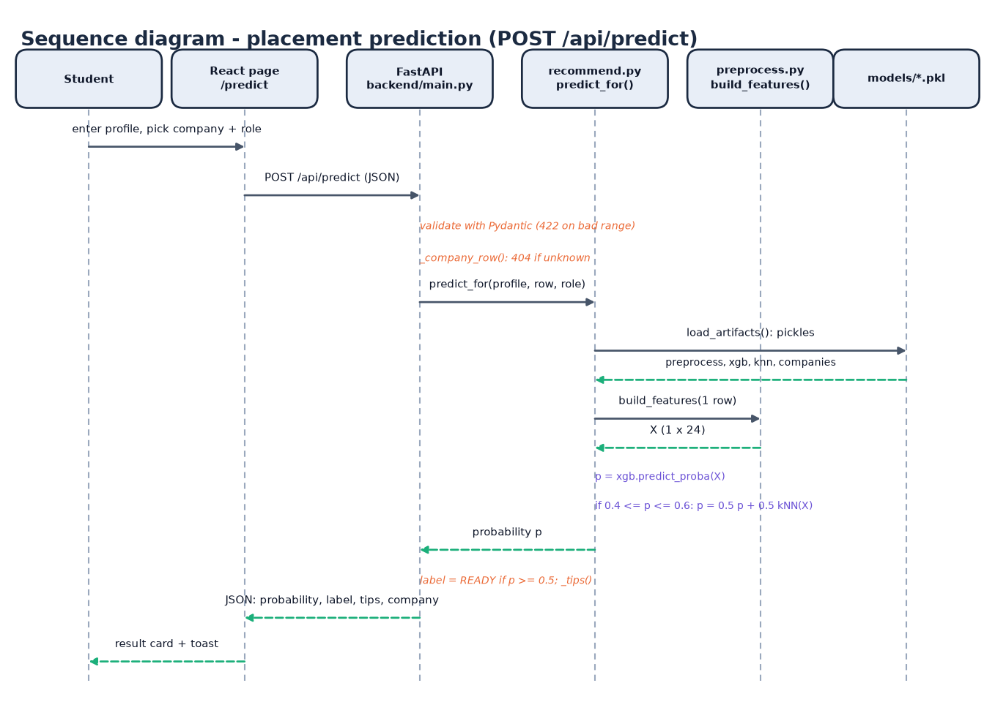
Figure 7: Sequence diagram of POST /api/predict, the main flow of the system.
The student enters a profile on the Eligibility page and picks a company and a role. The page posts JSON to /api/predict. FastAPI validates the body with Pydantic (422 on a bad range) and looks the company up (404 if unknown). predict_for loads the four pickles, build_features turns the single row into a 1 x 24 vector, the calibrated XGBoost model gives a probability and, when the probability lies between 0.4 and 0.6, it is averaged with the kNN probability. The endpoint labels the result PLACEMENT READY at 0.5 or above, adds the skill-gap tips and returns JSON; the page shows a result card and a toast.

Use-case diagram
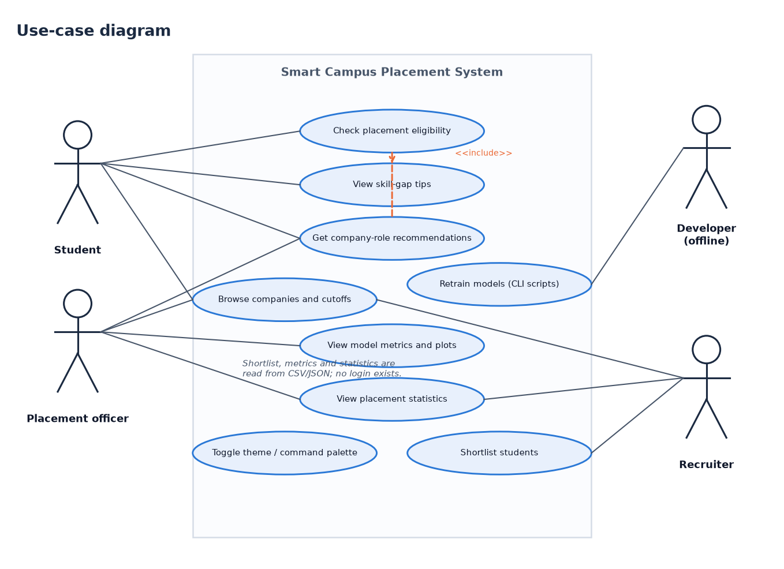
Figure 8: Use-case diagram with three user roles and one offline developer role.
A student checks placement eligibility, reads the skill-gap tips (an included use case), gets company-role recommendations and browses the companies with their cutoffs. A placement officer views the model metrics and plots and the placement statistics, and may use the recommendations and the company board. A recruiter shortlists students and also reads the company board and the statistics. The developer retrains the models with the three scripts in src/; this role is offline because the interface cannot retrain. There is no login: every use case is open to anyone who can reach the server.

Entity-relationship diagram
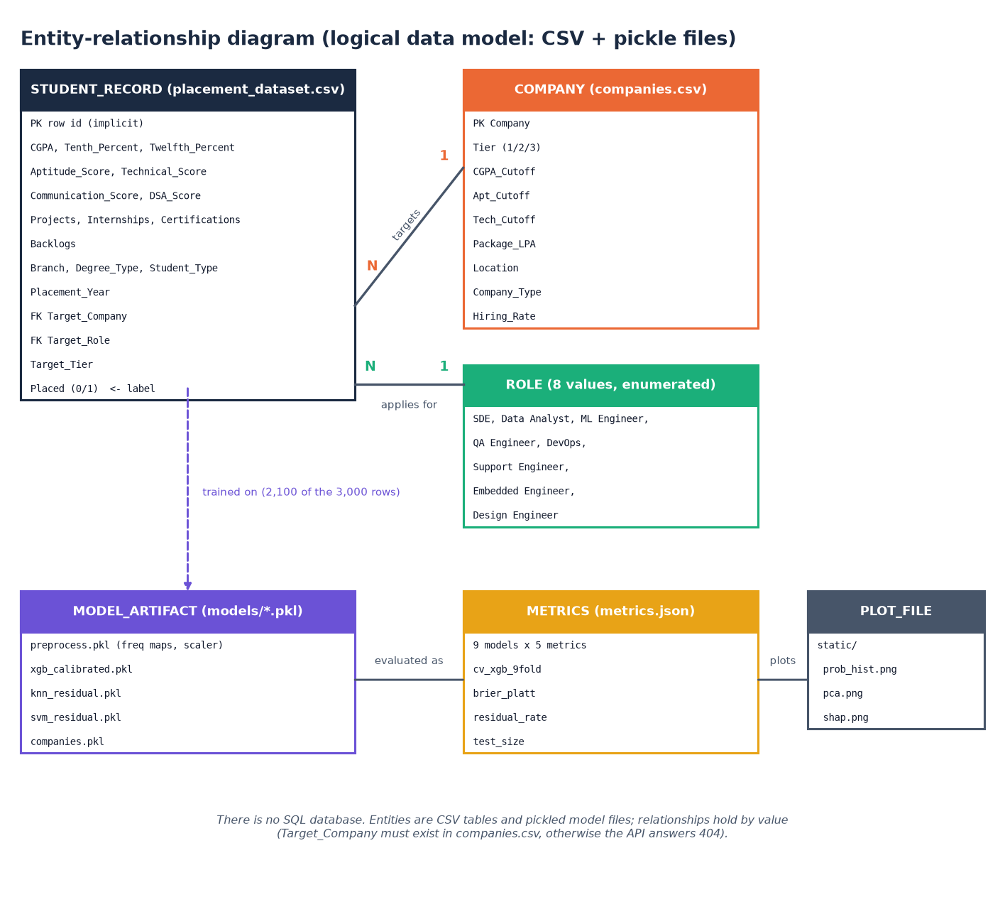
Figure 9: Entity-relationship diagram of the logical data model (CSV and pickle files).
The system has no SQL database, so the diagram shows the logical model of its files. STUDENT_RECORD (19 columns) targets one COMPANY and one ROLE; many students may target the same company. MODEL_ARTIFACT is trained on the student records, METRICS records how the models were evaluated and PLOT_FILE holds the three images. Relationships are enforced by value only: a target_company that is not in companies.csv makes the API answer 404.

Flowchart of the core algorithm
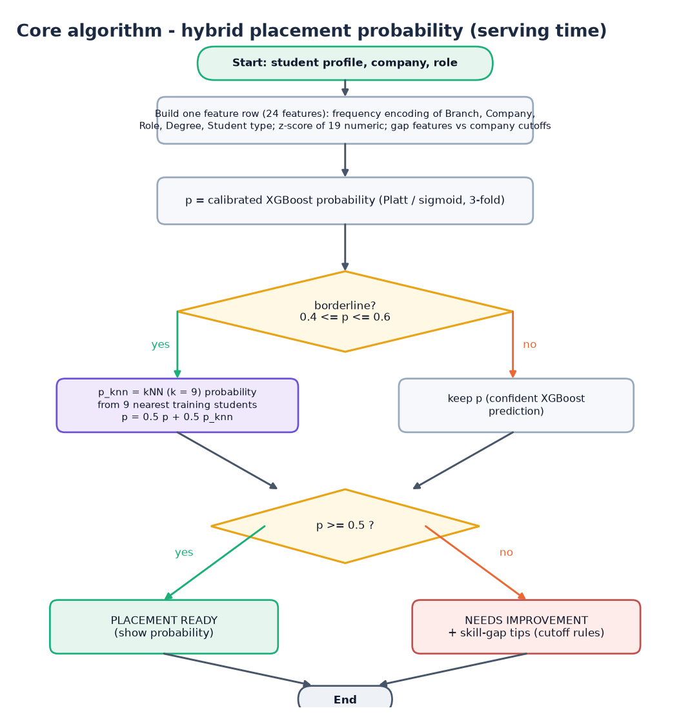
Figure 10: Flowchart of the hybrid placement probability computed at serving time.
A feature row of 24 values is built for the student, company and role. The calibrated XGBoost model gives p. If p lies in the borderline band 0.4 to 0.6 the kNN model (k = 9) is consulted and p becomes 0.5 p + 0.5 p_knn; otherwise p is kept. A probability of at least 0.5 is labelled PLACEMENT READY, anything lower NEEDS IMPROVEMENT with skill-gap tips. The band is used because these are the cases where the global model is least sure.

Training pipeline
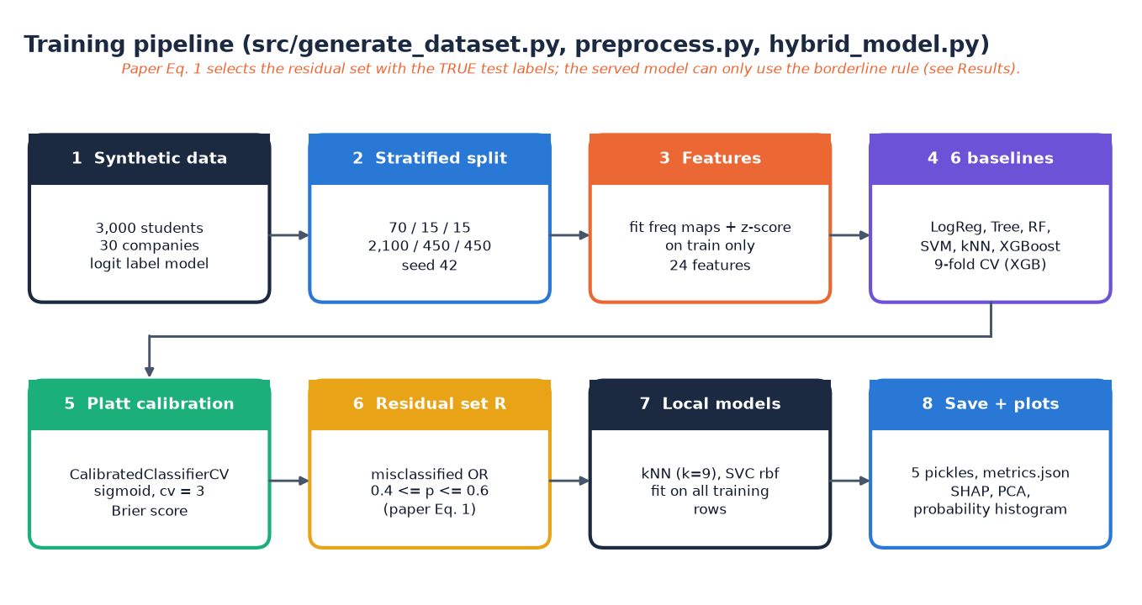
Figure 11: Training pipeline of src/generate_dataset.py, preprocess.py and hybrid_model.py.
Eight steps: generate the data, split it 70/15/15 (2,100 / 450 / 450, seed 42), fit the encodings and scaler on the training split only, train six baselines with 9-fold cross-validation for XGBoost, calibrate XGBoost (sigmoid, three folds), define the residual set (Equation 1 of the technique paper [2]), fit the kNN and SVM local models and save five pickles, metrics.json and the SHAP, PCA and histogram plots. The note on the figure matters: the residual set of Equation 1 uses the true labels of the evaluated rows, which a deployed system does not have (Section 6.6).

Flowchart of the recommendation algorithm
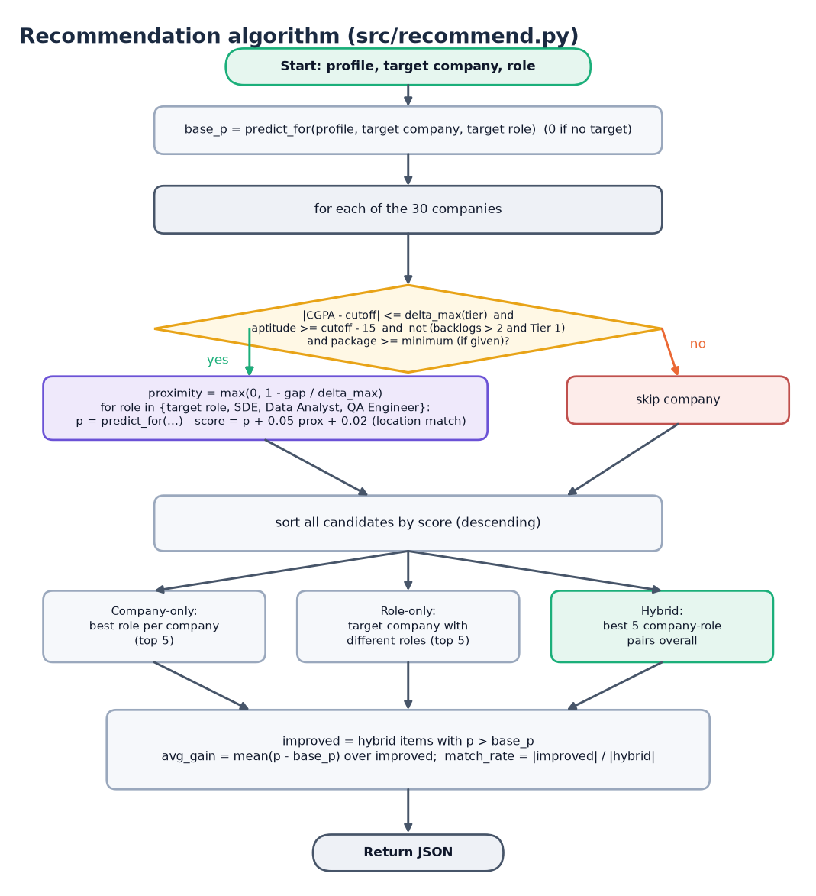
Figure 12: Flowchart of recommend() in src/recommend.py.
The base probability of the student's own target is computed first (0 when no target is given). Each company is then tested against the feasibility rules; a feasible company is scored for four roles and each candidate receives score = p + 0.05 x proximity + 0.02 x location bonus. Candidates are sorted by score and three lists are cut from them: company-only (best role per company), role-only (the target company with other roles) and hybrid (the best five pairs). The average gain and the match rate are computed over the hybrid items that beat the base probability.

